Chapter 18 - Viewpoint

“The most dangerous strategy is to jump a chasm in two leaps.”

- Benjamin Disraeli

DatabaseAdministration (DBA) on Teradata

1. Data Dictionary tables and views

2. System hierarchy and Space management

3. Users, Databases, Access Rights, Roles, and Profiles

4. Administrator and System Utilities

5. Teradata Administrator, Viewpoint , DBSControl

6. How to use the archive facility to do Archive, Restore, and Recovery procedures

7. Protection Features

8. Work with user community to help with adding new applications

The Teradata DBA has long been celebrated as one of the most important individuals in a Teradata data warehouse. An experienced DBA is a respected asset who is much needed in a large data warehouse. These professionals can make a huge difference in how smoothly systems run and are vital when problems arise.

Viewpoint

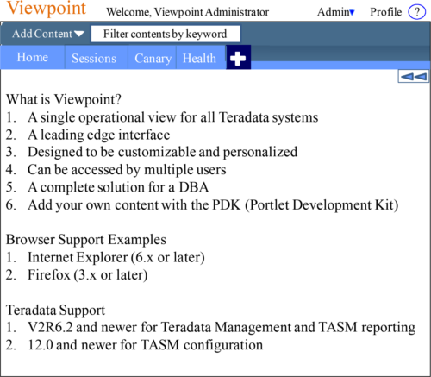

**Viewpoint** now contains an **Aster Data** portlet !

Logginginto Viewpoint

Logging on to the Viewpoint portal begins your session and therefore you can now begin working with the Teradata Viewpoint portal.

1. Open a browser.

2. Enter the address for your Teradata Viewpoint portal.

3. Log on to the Teradata Viewpoint portal.

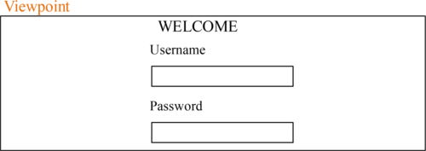

Put in your Username and Password to login to the Viewpoint Portal. You can set up your Viewpoint for auto-provisioning which means, if your system is set up to create a user profile automatically, the username and password you enter are authenticated against your Teradata username and password the first time you log on to Viewpoint.

TheFirst Time you Login to Viewpoint

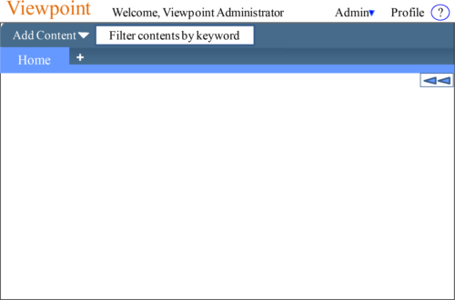

Above, is the screen you will see the first time you login to Viewpoint. There is almost nothing there but an Add Content menu and the Home tab. You will Add Content on the Home Page, or you will hit the + sign to add a new page.

TheAdd Content Menu for Monitoring

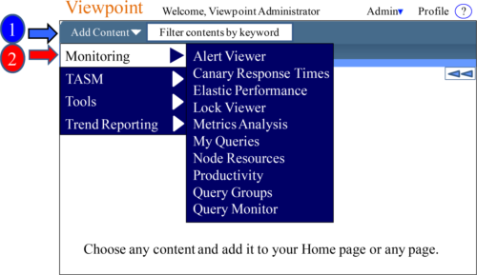

The drop down menu next to Add Content will provide a menu of content that you can select, and it will add that content to the desired page. The above shows the Monitoring content menu. You can Add Content on the Home Page or you will hit the + sign to add a new page where you can then Add Content. The Add Content menu allows you to place content on the pages and arrange them in a design customized for you.

TheAdd Content Menu for TASM

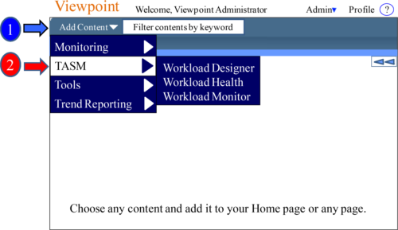

The drop down menu next to Add Content will provide a menu of content that you can select, and it will add that content to the desired page. The above shows the Monitoring content menu. You can Add Content on the Home Page, or you can add a new page where you can then Add Content. The Add Content menu allows you to place content on the pages and arrange them in a design customized for you.

TheAdd Content Menu for Tools

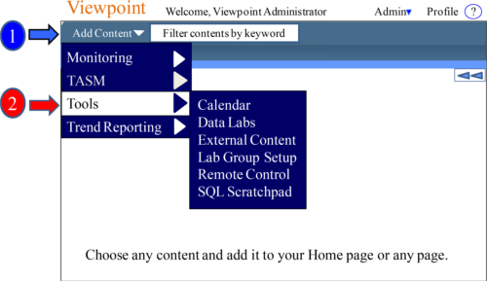

The drop down menu next to Add Content will provide a menu of content that you can select, and it will add that content to the desired page. The above shows the Tools content menu. You can Add Content on the Home Page or you will hit the + sign to add a new page where you can then Add Content. The Add Content menu allows you to place content on the pages and arrange them in a design customized for you.

TheAdd Content Menu for Trend Reporting

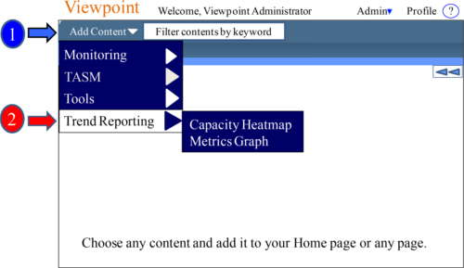

The drop down menu next to Add Content will provide a menu of content that you can select, and it will add that content to the desired page. The above shows the Trend Reporting content menu. You can Add Content on the Home Page or you will hit the + sign to add a new page where you can then Add Content. The Add Content menu allows you to place content on the pages and arrange them in a customized design.

Addingyour first Content

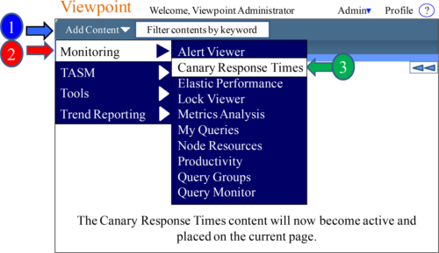

The drop down menu next to Add Content will provide a menu of content that you can select, and it will add that content to the desired page. The above shows the Monitoring content menu. In this example, we have chosen Canary Response Times, which means this will be placed on the page. Check out the next page and see what just happened!

Howthe Page looks after you add your first Content

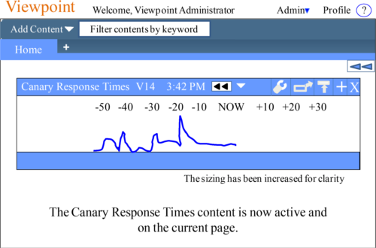

We just added the Canary Response Times content from the Add Content menu. Now, the content is active on our page. We can easily move the content where we want on the page. We can also move it to another page or delete it.

AddingAdditional Pages

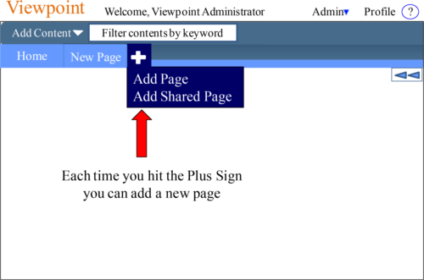

Viewpoint allows you to add pages and name the pages in the tab. Multiple tabs (pages) can have the same name. This allows you to organize Viewpoint in any way you want. This is your view point of the system, so customize the way you want.

TheFundamentals of Viewpoint Pages and Portals

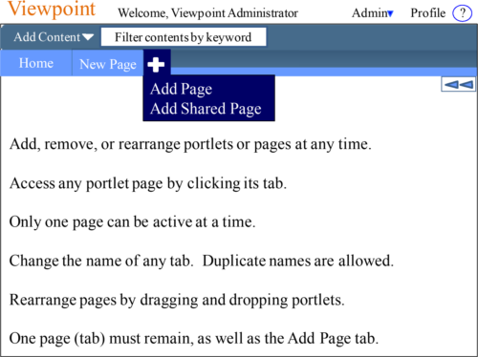

When you click on a tab, it becomes the Active Page, and Viewpoint continually updates the portals on that Active Page. Only one page is active at any one time. To change the name of a tab, click on the Active Page tab, and then you can change the name.

AddingMultiple Portals to a Single Page

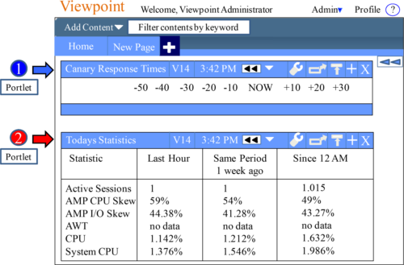

We have added both the Canary Response Times Portlets and the Todays Statistics Portlets onto a single page. This further allows you to customize your pages to get the view point that you desire. When you click on a particular Portlet, it lights up.

AllPortals to Their Individual Tab

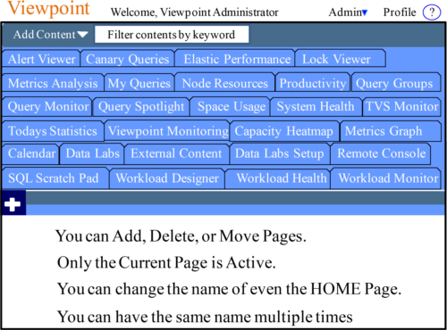

Here is an extreme example of creating a Portal page for every single piece of content. Each and every time we went to “Add Content”, and we placed that content on the current page. Then, we hit the Plus and added a new page and went to Add Content again.

PortletControls

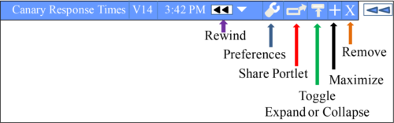

1) Rewind allows a portlet to be set to display data from a previous point in time.

2) Preferences are used to specify what information is displayed, time intervals for reporting, and other features that help you customize the functions of a portlet.

3) Share Portlet captures a customized version of a portlet for use by other users. Only the Viewpoint Administrator can make a customized portlet available to share.

4) Collapse toggles the portlet closed or open.

5) Maximize toggles the portlet to fill the portal page, covering up the other portlets.

6) Remove will remove the portlet and all its settings from the active portal page.

TheRewind Control

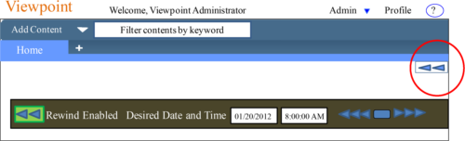

Rewind allows a portlet to be set to display data from a previous point in time. Rewind and view data that corresponds to dates and times in the past, and compare it to data for a different period. You can rewind the data for some or all portlets on a portal page to a previous point in time, such as the exact moment in time when a job failed. Rewinding is especially useful for identifying and resolving issues. You can rewind data only as far back as the data is available. This feature is not available for portlets that have portlet-specific methods for reviewing data over time. Using the rewind toolbar, you can enter a specific date and time as well as scroll through the data in increments of seconds, minutes, hours, or days.

QueryMonitor Overview

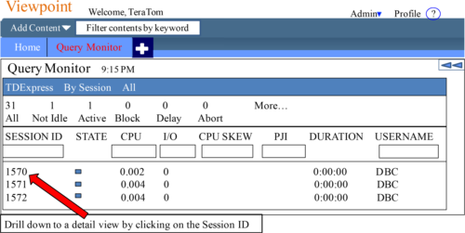

The Query Monitor portlet allows you to view information about queries so you can spot problem queries. This view gives you the ability to decide if a query is important, well written or poorly written. Problem queries can be handled by changing the priority or workload, releasing the query, or aborting the query. You can even abort the entire session. You can take these actions for one query or session, or multiple queries, or multiple sessions at a time. Query Monitor puts the DBA back in control of problems.

QueryMonitor Details View

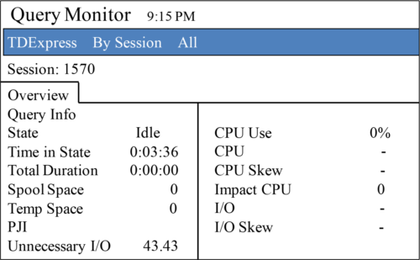

1. Overview shows key statistics for a session. A Value exceeding thresholds will automatically be highlighted.

2. SQL is shown for the selected query.

3. Explain steps for the query, including step statistics and explain text.

4. Blocked By details about other queries that are blocking this query.

5. Delay details rules delaying this query.

6. Query Band displays the query band name and value for the selected query.

QueryMonitor Actions

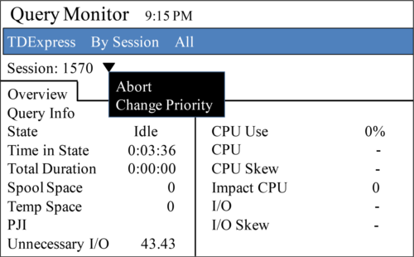

Use the menu to change the priority or workload, release a query, or abort a query, or session, for one query or session at a time.

Use the Next and Previous buttons to move through sessions without returning to the summary view.

MyQueries

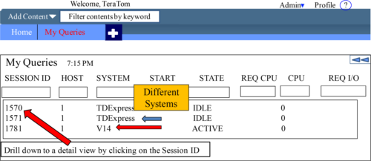

The My Queries portlet allows you to view and manage your queries across multiple Teradata Database systems. You can see the Summary View or click on a Session ID and see the details view.

The PREFERENCES view allows you to select one or more Teradata Database systems, and then select one or more users per system to monitor. From this view, you can also select a format for the SQL that appears in the query details view.

Calendar

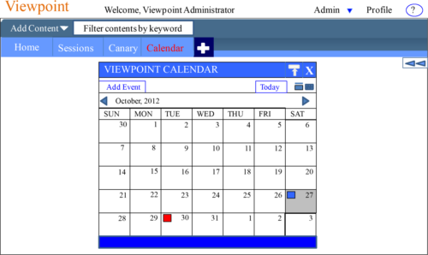

Calendar Portlet schedules events, not to run automatically, but to allow the DBA team to keep track of events. The Calendar above has two scheduled events (October 27 and October 30). An event in blue is a normal event, but an event in red is High Priority!

SystemHealth

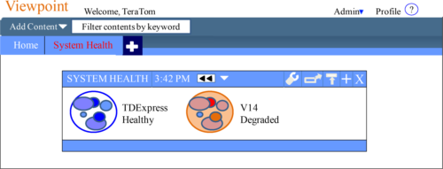

The System Health Portlet allows users to monitor and display the status of a selected Teradata system. Multiple systems can be displayed, and the DBA can choose which of those systems will be displayed. Colors for healthy systems are blue, and those in orange and red are degraded or critical.

SystemHealth Drilldown

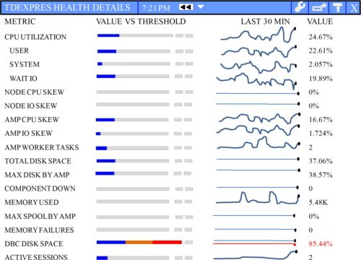

Load an object tree inside the SQL Scratchpad in order to drop and drag for queries.

SpaceUsage

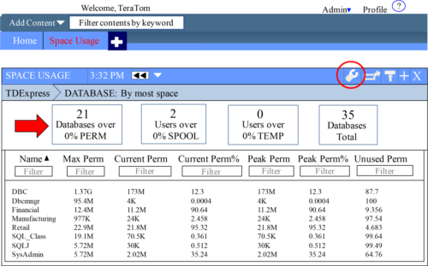

The Space Usage Portal shows Perm, Spool, and Temp Space. You can set thresholds in the Preferences Tab (circled in Red) or press on the Space report desired (red arrow).

SpaceUsage Preferences

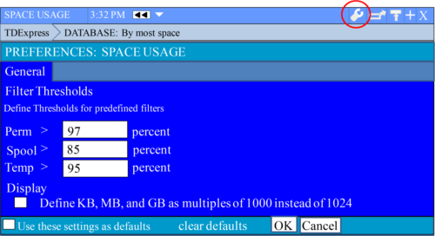

You can set thresholds in the Preferences Tab (circled in Red) for pre-defined filters. Then, when you go to the Space Usage Portal, the Space Report shows anyone their pre-defined filter. You can also filter on the main page.